**Priming: Using the Hidden Power of Language for Superior**

**Client Outcomes and Self-Improvement (1.00-1.5 hrs.)**

**Clifton Mitchell, Ph.D.**

**423-854-9211 home office, 423-930-3677 cell**

**email:** [**cliftmitch@comcast.net**](mailto:cliftmitch@comcast.net)

**website: www.cliftonmitchell.com**

**Program Description:**

Most people know more about how to program their VCR than their own mind! Dr. Mitchell’s presentation, *Priming: Using the Hidden Power of Language for Superior Client Outcomes and Self-Improvement*, will teach you how to program the first computer you ever owned--your mind. This dynamic keynote or breakout session introduces the audience to world of priming through a discussion of the priming that occurs in our everyday lives. It then addresses the scientific research, demonstrates the phenomena, and explains how priming can be utilized to radically intensify therapeutic communications and improve outcomes. In addition, these principles provide you with the mental tools necessary for molding yourself into the person you want to be and for reaching your personally desired goals.

Specifically, the priming research of the last 20 years has determined that humans are controlled by an unconscious guidance system profoundly more than ever conceived. Priming occurs when something stimulates and triggers behavior. Semantic priming has confirmed the hidden power of words to stimulate preparatory thoughts that trigger new behavior with or without conscious awareness. The most significant finding is that unconsciously created goals can be equal or more powerful than conscious goals and, amazingly, that goals do not require an act of will to be acquired. Yet, the nuances of how new behaviors are stimulated through the precise, meticulous use of language are rarely discussed relative to the therapeutic dialogue and self-improvement.

For the past 30 years, Dr. Mitchell has keynoted at hundreds of conventions and business organizations on effective techniques for improving communications and overcoming bad habits through an understanding of mental programming. He is known for providing practical information in a uniquely entertaining, fast-paced style filled with hilarious examples from our everyday lives. This laugh-while-you-learn presentation is ideal for mental health professionals, leadership and sales personnel, and anyone desiring change in their life.

**Learning Objectives**

At the conclusion of this presentation, the learner will have the knowledge required to:

1. Define what priming is and understand how and why it has such a significant impact

on mental processing and the stimulation of behavior.

2. Increase the impact of therapeutic communication by incorporating priming

techniques into the client-therapist dialogue.

3. Create effective mental programming for breaking bad habits and reaching personally

desired goals.

**Presentation Outline**

* The Incredible Brain
* The Dominant Thought: The Primary Principle That Governs All Thinking
* Priming in Our Everyday Lives
* Understanding the Conscious and Subconscious Minds
* The Importance of Talking to the Subconscious
* Mental Programming vs Willpower
* The Hidden Power of Words
* Recent Priming Research
* Priming Principles Applied to Therapeutic Dialogue

**Bio – Longer Version**

Clifton Mitchell Ph.D.is an international clinical trainer and keynote speaker who has a love for teaching and over 23 years of training experience. He delivers practical information in a uniquely entertaining, fast-paced style that is filled with humor and examples from his experience in mental health. For the past 20 years Dr. Mitchell has keynoted at conventions and spoken to hundreds of mental health organizations, businesses, and leadership groups on techniques for improving communications and for creating change through an understanding of how the mind works and the scientific study of language known as linguistics. In his book, *Effective Techniques for Dealing with Highly Resistant Clients*, he explains cutting-edge approaches for managing psychological resistance that he teaches in his resistance management trainings. He has also trained thousands of mental health professionals in the management of difficult, perplexing legal and ethical issues in a seminar that he presents in an exciting, dynamic game show format. He is a contributing author in therapy books and has published in numerous professional journals including the *Psychotherapy Networker, Psychotherapy in Australia, Journal of Personality Assessment, Perceptual and Motor Skills, Psychology and Education, Journal of Psychological Type, The Professional School Counselor, Vistas,* and *The Advocate*. His research includes investigations of therapeutic resistance, legal and ethical issues, subliminal message tapes, stress and coping, PMS, and personality types. His ideas and writings have also been published in *Men’s Health Today* and *Barron’s Financial Weekly*. Dr. Mitchell is currently a professor Emeritus at East Tennessee State University in Johnson City, Tennessee, where he received the Teacher of the Year award in 2002. For more information please visit: www.cliftonmitchell.com.

**Bio – Shorter Version**

Clifton Mitchell Ph.D. is an international clinical trainer and keynote speaker with over 23 years of training experience. He delivers practical information in a uniquely entertaining, fast-paced style that is filled with humor and examples from his experience in mental health. Dr. Mitchell has trained at hundreds of mental health conferences on techniques for improving therapeutic communications and for creating change through an understanding of how the mind works and the scientific study of language known as linguistics. He is a contributing author in therapy books and has published in numerous professional journals including the Psychotherapy Networker, Psychotherapy in Australia, Journal of Personality Assessment, Perceptual and Motor Skills, Psychology and Education, Journal of Psychological Type, The Professional School Counselor, Vistas, and The Advocate. Dr. Mitchell is Professor Emeritus at East Tennessee State University where he received the Teacher of the Year award in 2002. For more information please visit: www.cliftonmitchell.com.

**Attendees Level of Understanding & Prior Experience Needed**

This program is suited for all levels of understanding intermediate to advanced. Minimal counseling experience needed to understand and apply to the concepts.

**AV Needs**

*Wireless* lapel microphone, projector, screen, flip chart. I will bring my own computer. No audio required. A table on the left of stage (from audience perspective) ***with a power cord running to it*** from which to work and sell books. A podium is not necessary but can be used if available.

**Pictures:** (More pictures following pages.)

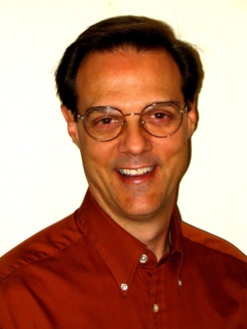

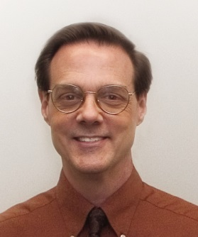

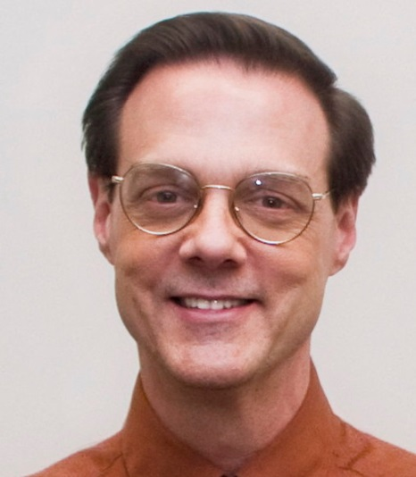



**Post Test Questions Multiple Choice Format**

1. Recent conservative estimates and research studies indicate that the brain is

processing approximately ______________ bits of information *per second*.

A. 1,000,000 (1 million)

B. 1,000,000,000 (1 billion)

C. 1,000,000,000,000 (1 trillion)

D. 100,000,000,000,000 (100 trillion)

Answer: C

2. The vast majority (95%+) of everyday human behavior is being process and

controlled by:

A. the conscious mind.

B. the subconscious mind.

C. both the conscious and subconscious minds as generally equal partners.

D. the unconscious mind.

Answer: B

3. The priming research has confirmed that:

A. effective goal creation requires clients’ full commitment to the outcome.

B. unconscious goals can be as or more powerful than conscious goals.

C. without ample willpower most goals are ineffective.

D. goals require conscious, deliberate focus to be useful.

Answer: B

4. Dr. Mitchell asserts that the subconscious mind is “governed” or “ruled” by:

A. the conscious mind.

B. the unconscious mind.

C. the dominant thought.

D. all of the stimuli present at the moment.

Answer: C

5. The first step in creating mental programming statements is to:

A. defeat all negative thoughts regarding the desired change.

B. define the positive opposite of what you are currently doing.

C. create a statement that you will do the new behavior.

D. describe what you are currently doing.

Answer: D

6. The most difficult step in mental programming is:

A. describing what you are currently doing.

B. defining the positive opposite of what you are currently doing.

C. making a present tense statement that you are doing what you want to do.

D. consistently repeating the new dominant thought statement.

Answer: D

7. One reasons priming works is because it triggers preparatory thoughts.

A. True

B. False

Answer: True

8. Dr. Mitchell asserts that good therapy utilizes priming consistently.

A. True

B. False

Answer: True

9. The priming research has confirmed that goal can be unconsciously stimulated.

A. True

B. False

Answer: True

10. Dr. Mitchell believes that time should always take time to refute the negative voice that is aroused by dominant thoughts.

A. True

B. False

Answer: False

**Post Test Questions True/False Format Only**

1. Recent conservative estimates and research studies indicate that the brain is

processing approximately 1,000,000,000,000 (1 trillion) bits of information *per*

*second*.

A. True

B. False

Answer: T

2. The vast majority (95%+) of everyday human behavior is being process and

controlled by both the conscious and subconscious minds as generally equal

partners.

A. True

B. False

Answer: F

3. The priming research has confirmed that goals require conscious, deliberate focus to

be useful.

A. True

B. False

Answer: F

**Diversity Statement**

Recently it appears that various guilds (APA, ACA, AAMFT, NASW, etc.) are increasingly demanding statements regarding relevance to diversity. The statement below is written in an attempt to provide material to satisfy these demands.

Diversity Statement: This training will discuss and explain the significance of semantic priming in the therapeutic dialogue. The application of priming principles necessitates an understanding of the different implications of words and their meaning in various cultural contexts. In addition, a major portion of the priming research has studied the impact of priming on social prejudices, particularly with regards to race and gender.

**References**

Bargh, J. A., & Chartrand, T. L. (1999). The unbearable automaticity of being.

*American Psychologist, 54*(7), 462-479.

Bargh, J. A., Chen, M., & Burrows, L. (1996). Automaticity of social behavior: Direct effects of trait construct and stereotype activation on action. *Journal of*

*Personality and Social Psychology, 71*(2), 230-244.

Gollwitzer, P. M. (1999). Implementation intentions: Strong effects of simple

plans. *American Psychologist, 54*(7), 493-503.

Kirsch, I., & Lynn, S. J. (1999). Automaticity in clinical psychology. *American Psychologist, 54*(7), 504-515.

Merrick, C, Farnia, M., Tiffany, J. K., Gazzaley, A., & Ezequiel, M. (2014). External

control of the stream of consciousness: Stimulus-based effects on involuntary

thought sequences. *Conciousness and Cognition, 33*, 217-225.

Mitchell, C. W. (2018). *Priming: Programming the Mind for Habit Change and Success*, Johnson City, TN, Mind Management Publishing.

Mitchell, C. W. (2007). *Effective techniques for dealing with highly resistant clients*

*(2nd ed.).* Johnson City, TN., Clifton Mitchell Publishing.